**Classification Assignment**

1. **Problem Statement:**

*The Hospital, Management asked us to create a predictive model which will predict the chronic kidney disease (CKD) based on the several parameters.*

1. **Basic Info about dataset**:

*Number of rows: 399*

*Number of columns: 25*

1. **Pre-processing method used:**

*get_dummies(dataset,drop_first=True)*

1. **A final model with good evaluation metric:**

*I got good results with AdaBoost Classification and QuadraticDiscriminantAnalysis_Classification models.*

1. **Screenshot of the results:**
2. *Random forest classification:*

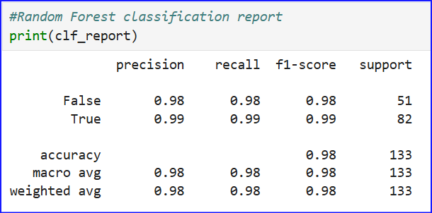

1. *Support Vector Classification – SVC:*

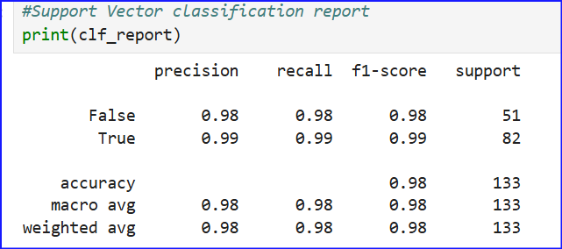

1. *Decision Tree Classification:*

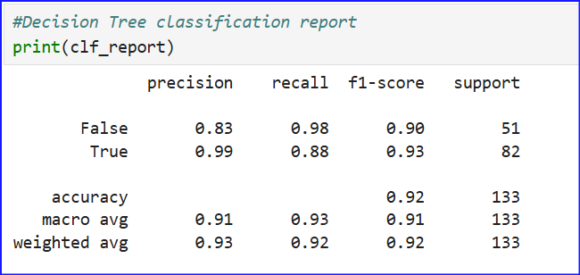

1. *KNeighbors Classification:*

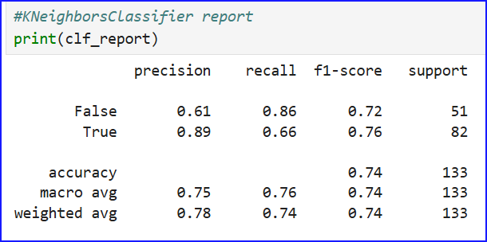

1. *GaussianNBClassification:*

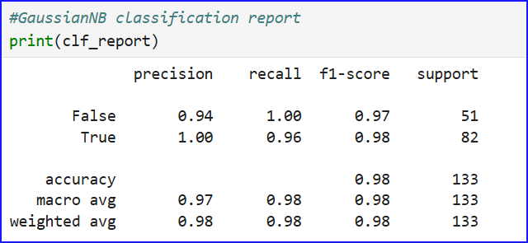

1. *MLP Classification:*

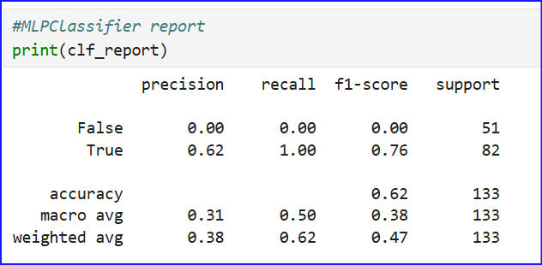

1. *AdaBoost Classification:*

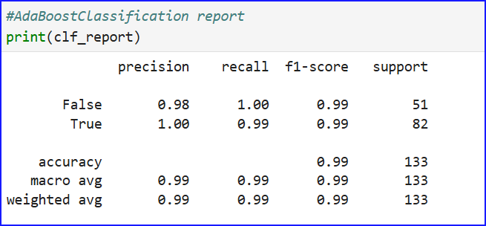

1. *QuadraticDiscriminantAnalysis_Classification:*

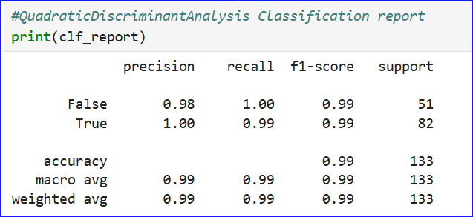

1. **Justification about the final model chosen:**

*By comparing with all other model, we see good accuracy with* ***AdaBoost Classification*** *and* ***QuadraticDiscriminantAnalysis_Classification*** *where we got accuracy = 0.99 and f1-score for True/False is 0.99/0.99.*

*Thank you Ramisha Mam & Rubhini Mam.*